PUBLIC MEETING NOTICE

THE Evaluation Committee WILL MEET AT 2:00 P.M. ON MONDAY AUGUST 3, 2020, IN THE JOSEPH S. YENNI BUILDING, 1221 ELMWOOD PARK BOULEVARD, PARISH ATTORNEY’S OFFICE, SUITE 701, JEFFERSON, LOUISIANA 70123.
THE COMMITTEE WILL MEET TO evaluate THE statements of qualifications submitted to the council clerk’S office pursuant to Resolution Number 135768 FROM INDIVIDUALS INTERESTED IN CONTRACTING WITH THE PARISH OF JEFFERSON TO SIT AS AN AD HOC HEARING OFFICER FOR THE BUREAU OF ADMINISTRATIVE ADJUDICATION ON THE EAST BANK OF JEFFERSON PARISH. The vendorS to be considered are LISTED BELOW:
- CHARLES V. CUSIMANO, II
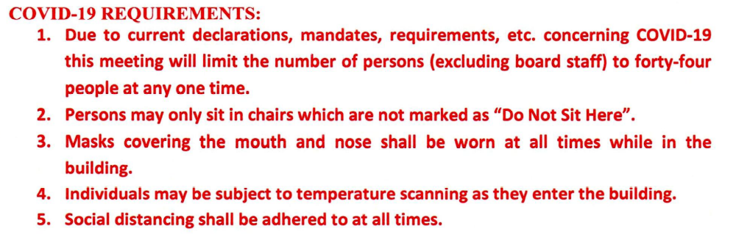
In accordance with provisions of the Americans with Disabilities Amendments Act of 2008, as amended, (ADA Amendments Act) Jefferson Parish shall not discriminate against qualified individuals with disabilities on the basis of disability in its services, programs or activities. If you require auxiliary aids or devices, or other reasonable accommodations under the ADA Amendments Act, submit your request to the ADA Coordinator at least 48 hours in advance or as soon as possible. A 72-hour notice is needed to request Certified ASL interpreters.

ADA Coordinator / Office of Citizens with Disabilities
1221 Elmwood Park Blvd., Suite 210, Jefferson, LA 70123
(504) 736-6086 ADA@jeffparish.net

